Risk assessment template - Excursions
Approved providers, nominated supervisors and family day care educators must ensure a risk assessment is carried out before children are taken outside the service premises on an excursion. Prior authorisation must also be obtained from parents or other authorised nominees.
ACECQA has prepared this template to assist services in undertaking risk assessments before children leave the service premises as part of an excursion, which services may wish to incorporate within their own risk assessment material.
Regulation 101 of the Education and Care Services National Regulations includes the minimum risk assessment considerations for excursions, including specific considerations when an excursion involves transporting children.
Note: A risk assessment is only required to be completed at least once for a 12 month period if the excursion is a ‘regular outing*’.
*Regular outing: means a walk, drive or trip to and from a destination that the service visits regularly as part of its educational program, and where the circumstances relevant to the risk assessment are substantially the same on each outing.

Service Name: Pulteney Grammar School OSHC
Excursion details Bounce inc Marleston
Date (s) of excursion.  If it is a regular outing include a description of when children are to be taken on regular outings. | Tuesday 9/12/25
Proposed activities.  List all activities that will take place during the excursion. | Catching a bus to Bounce at Marleston to complete some physical activity on Trampolines.
Pick up location and destination (s).  List each location travelled to and from as part of the excursion.  E.g. the museum, park for lunch and service. | Pulteney Grammar School OSHC – 190 South Terrace, Adelaide 5000 SA  Bounce Inc Adelaide – Richmond Road Marleston SA
Estimated departure and arrival times and duration of the excursion.  E.g. from the service to each destination and returning to the service. | Departure from service – 11:40  destination arrival– 12:00  Duration – 2 hours  Departure from destination – 2:15  Arrival to service – 2:45
Proposed route  You can include an image of the route sourced online. | 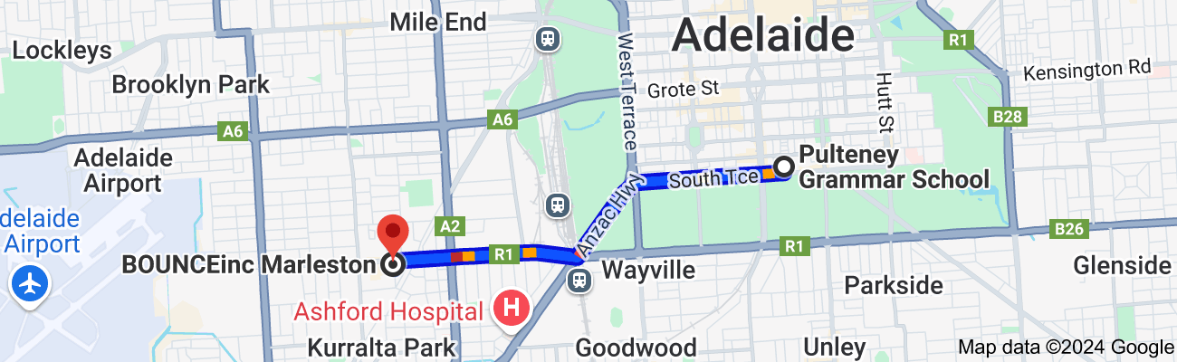
Means of transport  E.g. public bus, private bus, coach, private car, taxi, tram | Private charter bus – Willunga Charters in accordance with school policy
Requirements for seatbelts or safety restraints in your state or territory have been met. | Yes  Comment: Seatbelts are available for use on the bus, children are checked to ensure seatbelts are in place before bus begins
Number and full names of each adult involved in the excursion.  E.g. service staff, family members, volunteers | Barb Francis Coordinator  Nathan Pye Assistant Coordinator  Chelsea Cox  Hannah Douglas  Eliza white  Luca Altamura  Rhea Isaac
The number of educators / responsible adults, appropriate to provide supervision, and whether any adults with specialised skills are required.  E.g. for children’s individual needs | 8  Students with individual needs
The number of children involved in the excursion. | 50
Any water hazards during the excursion, including any risks associated with water-based activities?  If yes, detail in the risk assessment table below. | No
Educator to child ratio, including whether this excursion warrants a higher ratio.  Provide details in the risk assessment table below. | 1:8
Describe the process for entering and exiting the service premises and the pick-up location or destinations (as required); (include how each child is accounted for):
Children are dropped off in the bus zone next to the venue and are escorted by staff (front, back, middle) in to the venue through the car park. Children are picked up at the same area.
Children are counted as they line up at the service, prior to getting on the bus, as children are getting off the bus, at the venue, inside the venue, as children are leaving the room, as children are getting back on the bus, as they are getting off the bus upon arrival back at service and inside service room
Describe the procedures for embarking and disembarking the vehicle (include how each child is accounted for in embarking and disembarking):
A staff member will embark and disembark the bus before children begin to embark and disembark to ensure children accounted for. Another staff is standing at the entrance of the door of the bus, completing a head counts and other staff members are support the children within the line to ensure supervision is high at all times.
Excursion checklist – items to be readily available during the excursion
(please tick)
x□ First aid kit |  | x□ List of adults involved in the excursion
x□ List of children involved in the excursion |  | x□ Contact information for each adult
x□ Contact information for each child |  | x□ Mobile phone / other means of communicating with the service &  emergency services
x□ Medication, health plans and risk assessments for individual  children |  | x□ Other items, please list

Use the table below to identify and assess risks to the safety, health or wellbeing of children attending the excursion, and specify how these risks will be managed and minimised [regulation 101(1)]. This must include any risks associated with water-based activities.
Risk assessment
Activity | Hazard identified | Risk assessment  (use matrix) | Elimination/control measures | Who | When
Travel | Injury on the bus | Low | Educators ensure seatbelts are worn correctly & students sit sensibly. | Children/Staff | On Way and From Excursion
People | Incident with a member of the public | Low | Educators always keep children in a group & away from others in own designated area. | Children/Staff | Bounce
Food | Allergic reaction / choking | Moderate | Educators are trained and have first aid on site, as well as staff members at Bounce | Children/Staff | Bounce
Travel | Walking between the school to bus and bus to venue- student is lost. | Moderate | Educators ensure that all students are accounted for and are constant head counts. Lists of students are taken and checked off before and after getting on the bus/ leaving the movie complex. | Children | Bounce
Physical Activity | Injury on play equipment | Moderate | Educators to ensure high supervision to occur at all areas of the venue. Children are monitored closely for any injuries | Children/Staff | Bounce
Extra staffing | Students with additional requirements | moderate | Extra staffing will be rostered in addition to ratio numbers to accommodate individual student needs | staff | Throughout the excursion times
(Press tab to add more rows)

Likelihood
   | Insignificant | Minor | Moderate | Major | Catastrophic
  Almost certain | Moderate | High | High | Extreme | Extreme
  Likely | Moderate | Moderate | High | Extreme | Extreme
  Possible | Low | Moderate | High | High | Extreme
  Unlikely | Low | Low | Moderate | High | High
  Rare | Low | Low | Low | Moderate | High

Plan and Review
Plan prepared by: | Full name: Barb Francis  Signature: Barbara-Anne Francis  Role/Position: OSHC coordinator | Date:28/10/2025
Prepared in consultation with: | Full name: Nathan Pye  Signature:N Pye  Role/Position: Assistant Coordinator /Educators
Communicated to all relevant staff: | Yes  Comment if needed:
Vehicle safety information reviewed and attached: | Yes  Comment if needed:
Risk assessment to be evaluated and reviewed on:  A risk assessment must be undertaken prior to an excursion being undertaken (and before seeking authorisation for that excursion to be undertaken - see regulation 102). If the excursion is a 'regular outing'*, a risk assessment must be undertaken at least annually. | Next 2026 vacation Care period

