Risk assessment template - Excursions
Approved providers, nominated supervisors and family day care educators must ensure a risk assessment is carried out before children are taken outside the service premises on an excursion. Prior authorisation must also be obtained from parents or other authorised nominees.
ACECQA has prepared this template to assist services in undertaking risk assessments before children leave the service premises as part of an excursion, which services may wish to incorporate within their own risk assessment material.
Regulation 101 of the Education and Care Services National Regulations includes the minimum risk assessment considerations for excursions, including specific considerations when an excursion involves transporting children.
Note: A risk assessment is only required to be completed at least once for a 12 month period if the excursion is a ‘regular outing*’.
*Regular outing: means a walk, drive or trip to and from a destination that the service visits regularly as part of its educational program, and where the circumstances relevant to the risk assessment are substantially the same on each outing.

Service Name: Pulteney Grammar School OSHC
Excursion details
Date (s) of excursion.  If it is a regular outing include a description of when children are to be taken on regular outings. | Thursday 11/12/25
Proposed activities.  List all activities that will take place during the excursion. | Excursion to Bonython Park to enjoy a picnic in the park and a play on the playground. All students will enjoy the great outdoors , challenging themselves on ply equipment, enjoy leisurely games and enjoying a picnic lunch.
Arrival and departure location and destination  (s).  List each location travelled to and from as part of the excursion.  E.g. the museum, park for lunch and service. | Pulteney Grammar School OSHC – 190 South Tce, Adelaide 5000 SA  Bonython Park- Tulya Wardli Park City of Adelaide 5000

Estimated departure and arrival times and duration of the excursion.  E.g. from the service to each destination and returning to the service. | Departure from service – 930am  Arrival to destination – 10.00am  Duration – 3 hours  Departure from destination – 1pm  Arrival to service – 1.30pm
Proposed route  You can include an image of the route sourced online. | 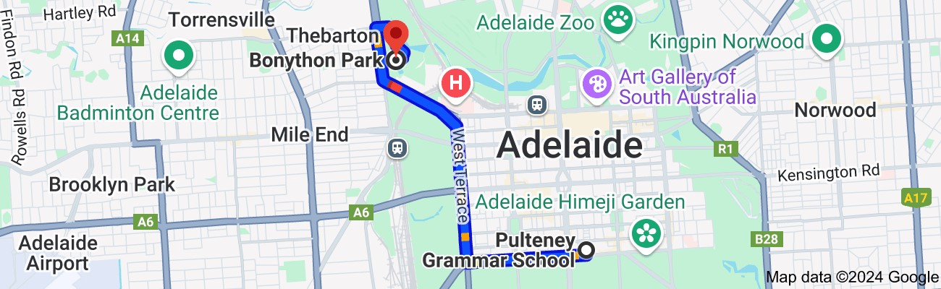
Means of transport  E.g. public bus, private bus,  coach, private car, taxi, tram | Bus
Requirements for seatbelts or safety restraints in your state or territory have been met. | yes

Number and full names of each adult involved in the excursion.  E.g. service staff, family members, volunteers | Barb Francis– OSHC Director  Nathan Pye – Assistant Director  Chelsea Cox – Certified supervisor | Eliza White – Educator  Jack Patterson - Educator  Luca Altamura – Educator  Rea Isaac - Educator
The number of educators /  responsible adults, appropriate to provide supervision, and whether any adults with specialised skills are required.  E.g. for children’s individual needs. | 1:8 ratio
The number of children involved in the excursion. | 1.8 ratio
Any water hazards during the excursion, including any risks associated with water-based activities?  If yes, detail in the risk assessment table below. | No
Educator to child ratio, including whether this excursion warrants a higher ratio. | 1:8 ( consideration if ratio requires for students with individual needs)

Provide details in the risk assessment table below.
Describe the process for entering and exiting the service premises and the pick-up location or destinations (as required); (include how each child is accounted for):
Prior to leaving the OSHC room, all students will be given a wrist band with medical students wearing a red band. All students are instructed to line up and a roll call will be performed, while another staff member will count. Once all children are accounted for, ,children will walk together to Gate 8 where we meet the bus.
A staff member will sweep OSHC , before closing the door and joining the group
Prior to boarding the bus, students will be counted Staff and children will board the bus , and be seated with seat belts fastened.
Children are counted by a roll call once seated and prior to the bus leaving.
On Arrival to destination, Children disembark 1 row at a time and line up for a roll call and to be counted. 1 staff member checks all students have left the bus prior to bus leaving.
Once all accounted for, children and staff make their way to the excursion to designated meeting point.
as they line up at the service, prior to walking to the park, as children are walking into the park, at the park, as children are leaving the park, as they are arriving back at service and inside service room. Attendance roll is taken before leaving the OSHC room, upon arrival at the park, upon leaving the park and upon arrival back at the OSHC room.
Describe the procedures for embarking and disembarking the vehicle (include how each child is accounted for in embarking and disembarking):
N/A
Excursion checklist – items to be readily available during the excursion
(please tick)
□ First aid kit |  | □ List of adults involved in the excursion
□ List of children involved in the excursion |  | □ Contact information for each adult
□ Contact information for each child |  | □ Mobile phone / other means of communicating with the service & emergency services

Use the table below to identify and assess risks to the safety, health or wellbeing of children attending the excursion, and specify how these risks will be managed and minimised [regulation 101(1)]. This must include any risks associated with water-based activities.
Risk assessment
Activity | Hazard identified | Risk assessment (use matrix) | Elimination/control measures | Who | When
Travel | Injury while transporting to the Park | Moderate | Educators ensure children are all wearing seatbelts | Children/Staff | On Way and From Excursion
People | Incident with a member of the public | Low | Educators keep children in a group at all times and are supervised at all  times. Educators address  the students in relation to interacting in our communities. | Children/Staff | During Excursion to Bonython Park
Food | Allergic reaction / choking | High | Educators are trained and have first aid equipment for student. | Children/Staff | Bonython Park
Nature Play | Injury while playing on outdoor playground and  nature play | moderate | Children to be highly supervised at all times  and ensure educators are supervising all areas | Children/Staff | Bonython Park
Bike Track | Injury while using bike track or skate equipment | moderate | Children to be heavily supervised at all times near bike tracks and skate equipment.  Educators to provide safety talk and instructions. | Children/Staff | Bonython Park
staffing | Ratio requirements may require to increase in regard to students with individual needs | moderate | Staffing will be rostered in regards to requirements for ratio and for individual needs of students | Staffing | During Excursion times

 |  |  |  |  | Consequence
Likelihood |  | Insignificant |  | Minor |  | Moderate | Major | Catastrophic
Likelihood | Almost  certain | Moderate |  | High |  | High | Extreme | Extreme
Likelihood | Likely | Moderate |  | Moderate |  | High | Extreme | Extreme
Likelihood | Possible | Low |  | Moderate |  | High | High | Extreme
Likelihood | Unlikely | Low |  | Low |  | Moderate | High | High
Likelihood | Rare | Low |  | Low |  | Low | Moderate | High

Plan and Review
Plan prepared by: | Full name: Barb Francis | Date: 28/10/2025
Signature:
Role/Position: OSHC Co Ordinator
Prepared in consultation with: | Nathan Pye  OSHC /Educators/Day Leader
Communicated to all relevant staff: | Yes  Comment if needed:
Vehicle safety information reviewed and attached: | Yes /  Comment if needed:
Risk assessment to be evaluated and reviewed on:  A risk assessment must be undertaken prior to an excursion being undertaken (and before seeking authorisation for that excursion to be undertaken - see regulation 102). If the excursion is a 'regular outing'*, a risk assessment must be undertaken at least annually. | Date: Next Vacacation Care December 2026

