Risk assessment and management template - Excursions

Approved providers, nominated supervisors and family day care educators must ensure a risk assessment is carried out before children are taken outside the service premises on an excursion. Prior authorisation must also be obtained from parents or other authorised nominees.
ACECQA has prepared this template to assist services in undertaking risk assessments before children leave the service premises as part of an excursion, which services may wish to incorporate within their own risk assessment material.
Regulation 101 of the Education and Care Services National Regulations includes the minimum risk assessment considerations for excursions, including specific considerations when an excursion involves transporting children.
Note: A risk assessment is only required to be completed at least once for a 12 month period if the excursion is a ‘regular outing*’.
*Regular outing: means a walk, drive or trip to and from a destination that the service visits regularly as part of its educational program, and where the circumstances relevant to the risk assessment are substantially the same on each outing.

Risk assessment and management template - Excursions
Service Name | Pulteney Grammar School OSHC
Excursion details | AFL MAX
Date (s) of excursion.  If it is a regular outing include a description of when children are to be taken on regular outings. | 1/10/2025
Proposed activities.  List all activities that will take place during the excursion. | Children will travel to AFL MAX on a charter Bus, Participate in supervised activities before returning to Pulteney Grammar School.
Pick up location and destination (s).  List each location travelled to and from as part of the excursion.  E.g., the museum, park for lunch and service. | Pulteney grammar school OSHC- 190 South Terrace, Adelaide 5000 SA  AFL MAX 32 Butler BVD, Adelaide Airport SA
Estimated departure and arrival times and duration of the excursion.  E.g., from the service to each destination and returning to the service. | Departure from service 915AM  Arrival destination :945AM  Duration 2 hrs  Departure from destination 1215PM  Arrival at service 145PM
Proposed route  You can include an image of the route sourced online. | 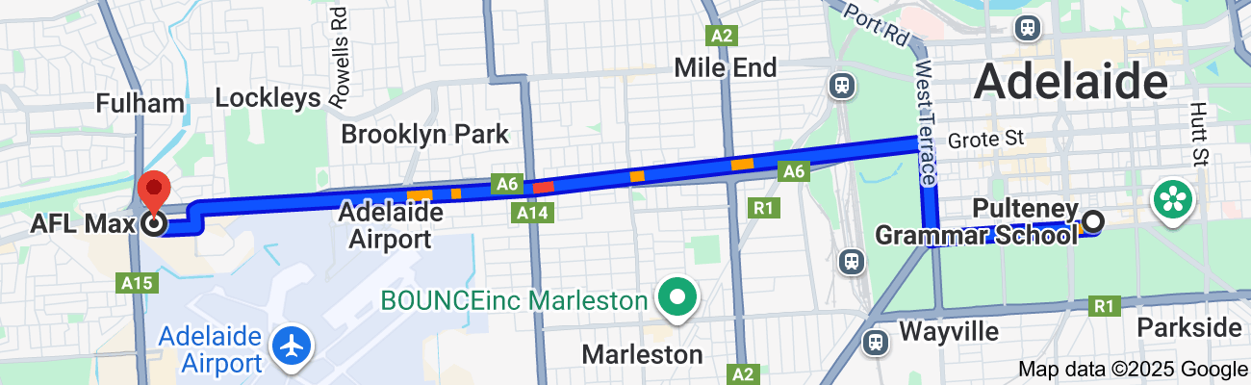
Means of transport  E.g., public bus, private bus, coach, private car, taxi, tram | Private Willunga Caoches Coaches bus
Requirements for seatbelts or safety restraints in your state or territory have been met. | Yes /  Comment: seatbelts are available on bus. educators facilitate application and check children to ensure seatbelts are in place before bus begins.
Number and full names of each adult involved in the excursion.  E.g., service staff, family members, volunteers | Barb Francis Coordinator Henry Lead Educator  Nathan Pye Assistant Coordinator Mei Lead Educator  Jack Patterson Lead Ed Daniel Kelly Educator  Katie Educator  Eliza White Educator
The number of educators / responsible adults, appropriate to provide supervision, and whether any adults with specialised skills are required.  E.g. for children’s individual needs. | 7 educators per 50 children 1.8 ratio  No students with additional needs
The number of children involved in the excursion. | 50
Any water hazards during the excursion, including any risks associated with water-based activities?  If yes, detail in the risk assessment table below. | No  Comment:
Educator to child ratio, including whether this excursion warrants a higher ratio.  Provide details in the risk assessment table below. | 1.8
Describe the process for entering and exiting the service premises and the pick-up location or destinations (as required); (include how each child is accounted for):
Staff and Students will exit OSHC service through the Kurrajong gate on South Terrace when the bus has arrived.
Students will then board the bus on South terrace.
There will be a head count before leaving the OSHC room, as students enter the bus and an attendance roll taken on the bus.
Private bus charter will drop students and educators off at the bus loading zone at the cinemas or in safest drop zone.
Educators will perform head count and attendance roll of students exiting the bus.
Educators will then walk students into the centre.
Once the excursion has finished students meet at the base camp and a head count to be performed as students exit the centre and board the bus immediately. OSHC staff will lead students in groups of 1.8 at a time. There will be a headcount as students board the bus and an attendance roll taken on the bus. Another attendance roll will be taken as students exit the bus upon arrival at Pulteney Grammar. Staff will walk students from the bus back to the OSHC room for a head count.
Each educator responsible for accounting for 8 individual children throughout the day.

Describe the procedures for embarking and disembarking the vehicle (include how each child is accounted for in embarking and disembarking):
2 educators to board bus first. 1 educator to stay at bus door, the remaining educators to be scattered through the student line ready to enter the bus (including 1 educator at the back). Students enter the bus 1 at a time with educator at the bus door performing a head count. Educators on board the bus help with seatbelts. Attendance roll taken once all educators and students are on the bus.
When arriving at destination 2 educators exit the bus first.
Another educator stands at the door to perform headcount. Students and educators then disembark in order of rows and form a safe line on the footpath. Once all students and educators are off the bus an attendance roll is taken.
Service devices only will be used on excursion
Excursion checklist – items to be readily available during the excursion
(Please tick)
x□ First aid kit |  | □x List of adults involved in the excursion
x□ List of children involved in the excursion |  | x□ Contact information for each adult
x□ Contact information for each child |  | x□ Mobile phone / other means of communicating with the service & emergency services
x□ Medication, health plans and risk assessments for individual children |  | □ Other items, please list

Use the table below to identify and assess risks to the safety, health or wellbeing of children attending the excursion, and specify how these risks will be managed and minimised (regulation 101(1)). This must include any risks associated with water-based activities.
Risk assessment
Activity | Hazard identified | Risk assessment  (use matrix) | Elimination/control measures | Who | When
Bus travel | Injury on bus | moderate | Educators ensure seatbelts are worn correctly and students sit sensibly. | Children/staff | On way and from excursion
Interactions with public | Incident with public | moderate | Educators keep children in a group at all times and away from others in own designated area. Educators remind students of respectful behaviour prior to, and during the excursion | Children/staff | Through Excursion at AFL MAX
AFL MAX | Lost child | moderate | Staff child ratio, students are organised into small group size and allocated a Educator. Throughout the excursions staff are involved in activity and a base camp is staffed at all times to accommodate as needed | Children/staff  event organisers | At all times throughout excursion
Excursion to AFL Max | Medical Episode | High | All students with a current medical plan wear a red arm band to alert to staff of medical awareness. All students with a identified medical condition will have access to medications during the excursion with at least 1 Educator with required first aid | Children/ Staff /vent Organisers | Throughout the excursion and at all times
(Press tab to add more rows)

Risk Matrix
Consequences | Likelihood
Consequences |  | Rare | Unlikely | Possible | Likely | Almost Certain
Consequences | Major | Moderate | High | High | Critical | Critical
Consequences | Significant | Moderate | Moderate | High | High | Critical
Consequences | Moderate | Low | Moderate | Moderate | High | High
Consequences | Minor | Very low | Low | Moderate | Moderate | Moderate
Consequences | Insignificant | Very low | Very low | Low | Moderate | Moderate

Plan and Review
Plan prepared by: | Full name: Barb Francis  Signature:  Role/Position: OSHC Coordinator | Date:20/8/2025
Prepared in consultation with: | Full name:Nathan Pye  Signature:  Role/Position: Assistant Coordinator
Communicated to all relevant staff: | Yes /  Comment if needed:
Vehicle safety information reviewed and attached: | Yes / No  Comment if needed:
Risk assessment to be evaluated and reviewed on:  A risk assessment must be undertaken prior to an excursion being undertaken (and before seeking authorisation for that excursion to be undertaken - see regulation 102). If the excursion is a 'regular outing'*, a risk assessment must be undertaken at least annually. | Date:20/8/2026

