Risk assessment template - Excursions
Approved providers, nominated supervisors and family day care educators must ensure a risk assessment is carried out before children are taken outside the service premises on an excursion. Prior authorisation must also be obtained from parents or other authorised nominees.
ACECQA has prepared this template to assist services in undertaking risk assessments before children leave the service premises as part of an excursion, which services may wish to incorporate within their own risk assessment material.
Regulation 101 of the Education and Care Services National Regulations includes the minimum risk assessment considerations for excursions, including specific considerations when an excursion involves transporting children.
Note: A risk assessment is only required to be completed at least once for a 12 month period if the excursion is a ‘regular outing*’.
*Regular outing: means a walk, drive or trip to and from a destination that the service visits regularly as part of its educational program, and where the circumstances relevant to the risk assessment are substantially the same on each outing.

Service Name: Pulteney Grammar School OSHC
Excursion details Mitcham cinemas
Date (s) of excursion.  If it is a regular outing include a description of when children are to be taken on regular outings. | October 3rd 2025
Proposed activities.  List all activities that will take place during the excursion. | Catching a bus to Wallis Cinemas at Mitcham to watch a movie
Pick up location and destination (s).  List each location travelled to and from as part of the excursion.  E.g. the museum, park for lunch and service. | Pulteney Grammar School OSHC – 190 South Tce, Adelaide 5000 SA  Mitcham Wallis Cinemas - Mitcham Shopping Centre, Level 1, 119 Belair Rd, Torrens Park SA 5062
Estimated departure and arrival times and duration of the excursion.  E.g. from the service to each destination and returning to the service. | Departure from service – 9.15AM  Arrival to destination – 9:45AM  Duration – 2.5 hours  Departure from destination – 12.15PM  Arrival to service – 12:45PM
Proposed route  You can include an image of the route sourced online. | 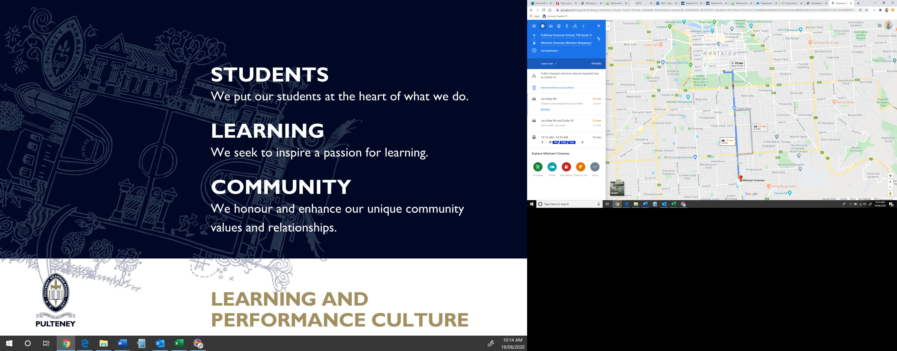
Means of transport  E.g. public bus, private bus, coach, private car, taxi, tram | Private charter bus – Willunga Coachlines in accordance with school policy
Requirements for seatbelts or safety restraints in your state or territory have been met. | Yes  Comment: Seatbelts are available for use on the bus, children are checked to ensure seatbelts are in place before bus begins
Number and full names of each adult involved in the excursion.  E.g. service staff, family members, volunteers | Barb Francis – OSHC Coordinator  Nathan Pye – Assistant Coorinator  Rhea Isaac Educator  Chelsea Cox Lead Ed |  | Hannah Douglas Eductor  Eliza White Educator  Daniel Kelly Educator
The number of educators / responsible adults, appropriate to provide supervision, and whether any adults with specialised skills are required.  E.g. for children’s individual needs. | 7
The number of children involved in the excursion. | 50
Any water hazards during the excursion, including any risks associated with water-based activities?  If yes, detail in the risk assessment table below. | No
Educator to child ratio, including whether this excursion warrants a higher ratio.  Provide details in the risk assessment table below. | 1:8
Describe the process for entering and exiting the service premises and the pick-up location or destinations (as required); (include how each child is accounted for):
Children leave Pulteney OSHC and walk in an orderly manner to the exit gate. A full roll call will be performed here. Once all students are accounted for, we proceed to the bus where a staff member will board first. Each student will board being counted on arrival. Once all students and Educators have boarded, a full roll call will take place.
Children are dropped off in a bus loading zone next to the shopping centre and are escorted by staff (front, back, middle) in to the shopping centre and up the stairs. Children are picked up at the same area.
Children are counted as they line up at the organised excursion,counted and separated into organised groups with Educator.
prior to getting on the bus, as children are getting off the bus, at the movie destination, inside cinemas room, as children are leaving the room, as children are getting back on the bus, as they are getting off the bus upon arrival back at service and inside service room, students will be accounted for prior to moving to the next destination
Describe the procedures for embarking and disembarking the vehicle (include how each child is accounted for in embarking and disembarking):
A staff member will embark and disembark the bus before children begin to embark and disembark to ensure children accounted for. Another staff is standing at the entrance of the door of the bus, completing a head counts and other staff members are support the children within the line to ensure supervision is high at all times.
Excursion checklist – items to be readily available during the excursion
(please tick)
□x First aid kit |  | □x List of adults involved in the excursion
□x List of children involved in the excursion |  | □ xContact information for each adult
□x Contact information for each child |  | □x Mobile phone / other means of communicating with the service &  emergency services
□x Medication, health plans and risk assessments for individual  children |  | □x Other items, please list

Use the table below to identify and assess risks to the safety, health or wellbeing of children attending the excursion, and specify how these risks will be managed and minimised [regulation 101(1)]. This must include any risks associated with water-based activities.
Risk assessment
Activity | Hazard identified | Risk assessment  (use matrix) | Elimination/control measures | Who | When
Travel | Injury on the bus | Moderate  Unlikely | Educators ensure seatbelts are worn correctly & students sit sensibly. | Children/Staff | On Way and From Excursion
Interactions with community | Incident with a member of the public | Low  possible | Educators keep children in a group at all times & away from others in own designated area. | Children/Staff | Mitcham Wallis Cinemas
Food | Allergic reaction / choking | Moderate  High | Educators are trained and have first aid on site, as well as staff members at the movies. | Children/Staff | Mitcham Wallis Cinemas
Travelling between service/ excursion | Walking between the school to bus and bus to movies- student is lost. | Moderate  Unlikely | Educators ensure that all students are accounted for and are constant head counts. Lists of students are taken and checked off before and after getting on the bus/ leaving the movie complex. | Children | Mitcham Wallis Cinemas and on our way/ back from excursions.
(Press tab to add more rows)

Risk Matrix
 |  | Consequence
Likelihood
   | Insignificant | Minor | Moderate | Major | Catastrophic
  Almost certain | Moderate | High | High | Extreme | Extreme
  Likely | Moderate | Moderate | High | Extreme | Extreme
  Possible | Low | Moderate | High | High | Extreme
  Unlikely | Low | Low | Moderate | High | High
  Rare | Low | Low | Low | Moderate | High

Plan prepared by: | Full name:Barb Francis  Signature:  Role/Position: | Date:28/8/2025  B-A Francis  OSHC Coordinator
Prepared in consultation with: | Full name:Nathan Pye  Signature:  Role/Position: Assistant OSHC Coordinator
Communicated to all relevant staff: | Yes / No  Comment if needed:
Vehicle safety information reviewed and attached: | Yes / No  Comment if needed:
Risk assessment to be evaluated and reviewed on:  A risk assessment must be undertaken prior to an excursion being undertaken (and before seeking authorisation for that excursion to be undertaken - see regulation 102). If the excursion is a 'regular outing'*, a risk assessment must be undertaken at least annually. | Date:August 2026

